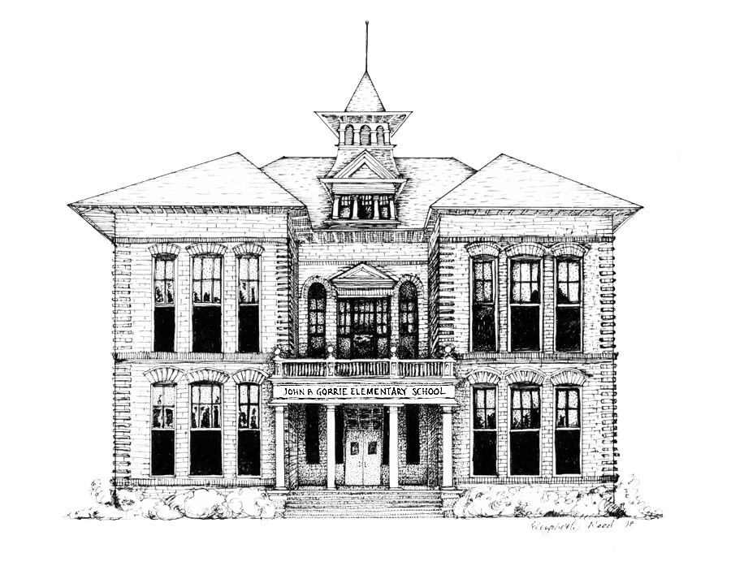

August 10, 2022

Dear Gorrie Families,

All parents know what it is like to provide the basic needs for our children on a daily basis. When it comes to our children’s education, the basics are not always enough. The teachers purchase extra curriculum enrichment materials, computer software, and additional art/ceramic supplies to make each classroom the best it can be for the students. We are asking for your help by making a $25.00 donation per child in August/September. This money will be divided equally among the teachers so these additional purchases can be made and every child benefits. Your support of this donation is much needed and appreciated. Please help make participation in this effort 100%.

Please return the attached envelope with your check made payable to “Gorrie Elementary”. Your child may give the envelope to his/her teacher, and it will be turned in to the office. Thank you again for your support and dedication to Gorrie.

Sincerely,

Marjorie Sandler

Principal